## Week 05

### W05 Learning Activities

1. [Sharing the Gospel Online](https://byui-cse.github.io/wdd130-ww-course/week05/prepare-gospel-sharing.html)
2. [HTML Table Element](https://byui-cse.github.io/wdd130-ww-course/week05/prepare-html-table.html)
3. [HTML Form Element](https://byui-cse.github.io/wdd130-ww-course/week05/prepare-html-form.html)
4. [Styling Forms with CSS](https://byui-cse.github.io/wdd130-ww-course/week05/prepare-css-form.html)
5. Optional Practice: [Quiz Form](https://byui-cse.github.io/wdd130-ww-course/week05/ponder-course-quiz.html) | [Page Evaluation Tool](https://byui-cse.github.io/wdd130-ww-course/grader/w05-quiz.html)

### Assignment

1. W05 Assignment: Rafting Site - [Contact Us Page](https://byui-cse.github.io/wdd130-ww-course/week05/prove-rafting-contactus.html) | [Page Evaluation Tool](https://byui-cse.github.io/wdd130-ww-course/grader/w05-project-contact.html)

**Overview**

HTML table elements are used to create visual representations of tabular data, allowing users to quickly compare and analyze different values.

"The **table** HTML element represents tabular data — that is, information presented in a two-dimensional table comprised of rows and columns of cells containing data." - MDN

**Prepare**

* Reference: [The Table Element](https://developer.mozilla.org/en-US/docs/Web/HTML/Element/table) - MDN

**Activity Instructions**

1. In your browser, navigate to the "*Try-It*" section on the MDN page: [The Table Element](https://developer.mozilla.org/en-US/docs/Web/HTML/Element/table).
2. **Ponder** the HTML and CSS used to create the example table.
3. You will be modifying the existing table shown below.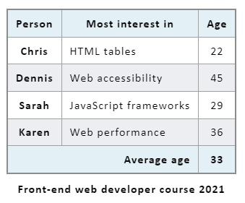Screenshot of original HTML Tableto look like this with a new "Department" column.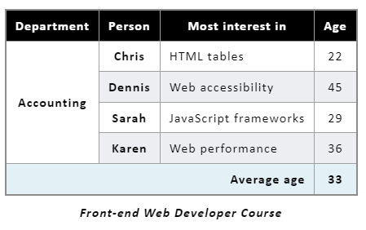Screenshot of modified HTML Table
4. In the HTML panel, add another column to the left of the existing table header (**<thead>**) section using a **<th>** and a column scope **scope="col"**.
5. Insert the heading of "**Department**" into that new heading cell.Check Your Understanding
6. <thead>
7. <tr>
8. <th scope="col">Department</th>
9. <th scope="col">Person</th>
10. <th scope="col">Most interest in</th>
11. <th scope="col">Age</th>
12. </tr>

</thead>

1. Add another table heading cell (**<th>**) to the existing first row (**<tr>**) of the table's body (**<tbody>**)
2. Insert the text of "**Accounting**" into the new cell.
3. Modify the new cell to span all four rows in the table body using **rowspan**.Check Your Understanding
4. <tbody>
5. <tr>
6. <th rowspan="4">Accounting</th>
7. <th scope="row">Chris</th>
8. <td>HTML tables</td>
9. <td>22</td>

</tr>

Why do we want to use **rowspan** on that first cell?

What is the role of the **scope** attribute in the table heading cells?

Providing a **scope** to a header cell in a table, indicates whether it applies to a row or column. Using the scope attribute appropriately improves the **accessibility** and **usability** of tables for all users, especially those relying on assistive technologies like screen readers.

1. Now notice that the **<tfoot>** content is not lined up correctly.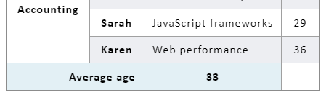Figure3: Screenshot of tfoot content issueHow can you fix this layout issue?Check Your Understanding
2. <tfoot>
3. <tr>
4. <th scope="row" colspan="3">Average age</th>
5. <td>33</td>
6. </tr>

</tfoot>

The **colspan** value was changed from 2 to 3.

1. Change the style of the table to use a black background in the table header row with white text.Check Your Understanding
2. thead th {
3. background-color: #000; */* This is shorthand HEX notation for #000000 */*
4. color: #fff;

}

1. Change the style of the table caption to be italic.Check Your Understanding
2. caption {
3. caption-side: bottom;
4. padding: 10px;
5. font-weight: 700;
6. font-style: italic;

}

Note that the font-weight value was changed from the semantic "bold" to "700". Using 700 is more precise and explicit, especially if you're working with a font that has multiple weights.

A complete example of the modification is provided here: [Table Modification Exercise](https://codepen.io/BYU-Idaho/pen/qBeGRrP) - CodePen

[**Back**](https://byui-cse.github.io/wdd130-ww-course/week05/index.html)